|  |
| --- |
| **North South University**  Department of Electrical & Computer Engineering  **UI**  **Spring 2020**  **Project Name : Online Bird Food Store**  **Course Code : CSE482**  **Section : 02**  **Group Number : 02** |



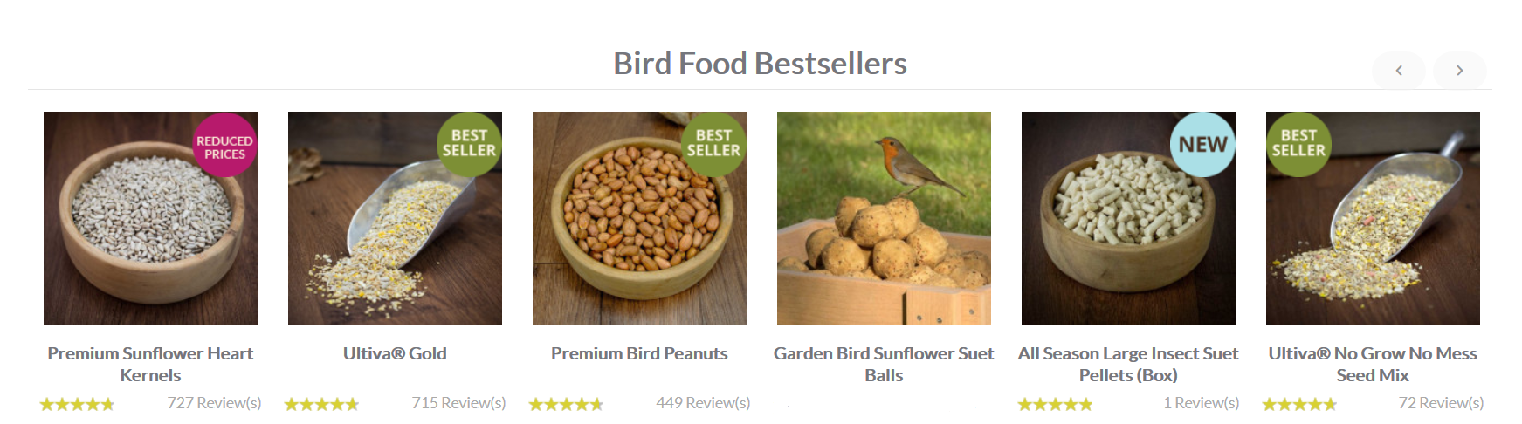



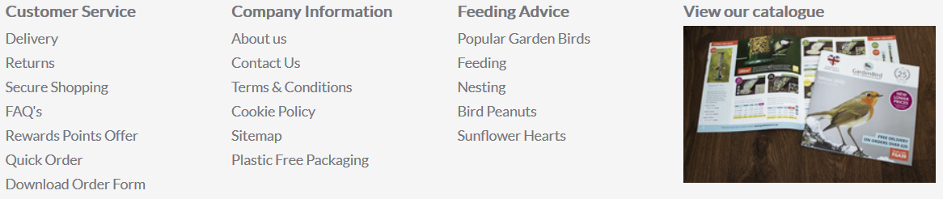

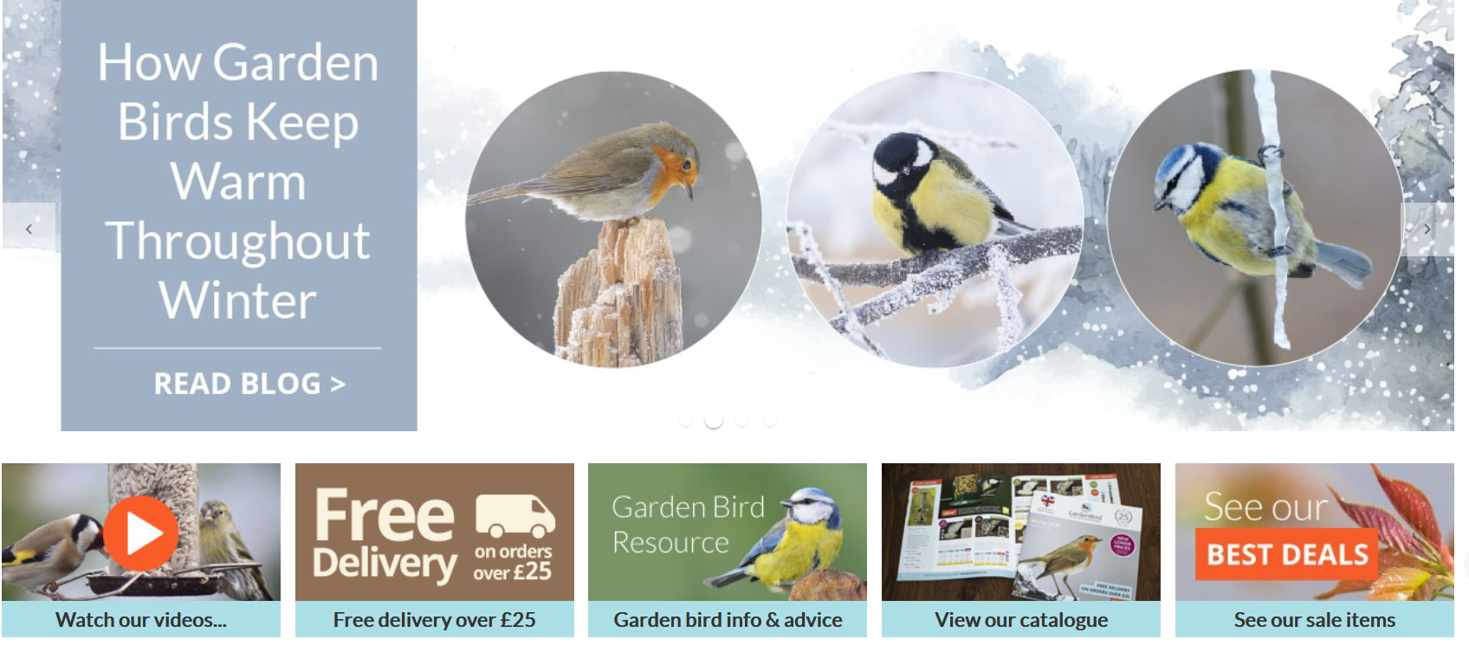

Ultiva® is a trusted and complete series of quality bird food seed mixes available only from GardenBird. Carefully formulated to provide nutritional enrichment, Ultiva® bird food features a balance of safe and effective ingredients, developed in accordance with strict BSA regulations, meaning the wild birds in your garden receive the very best food available.



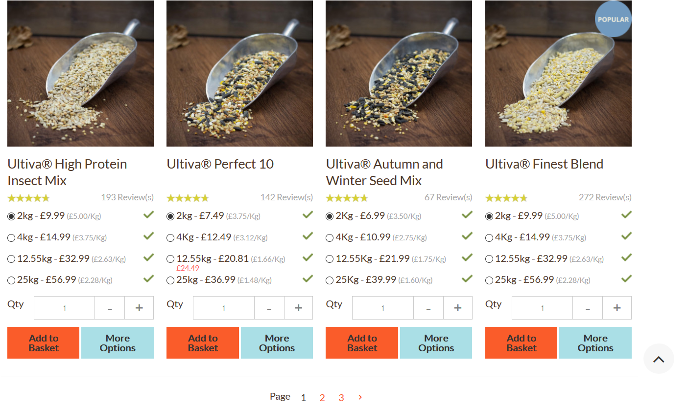

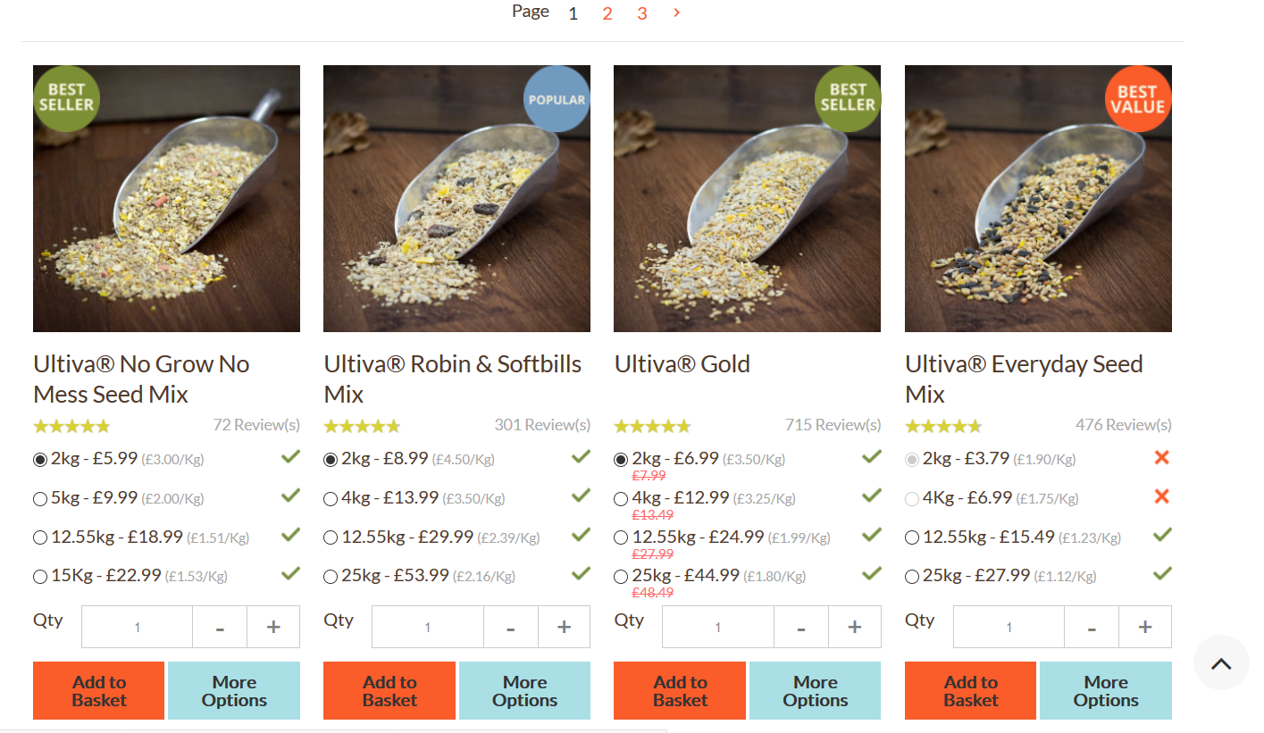

**Seed Mixes**

Ultiva® is a trusted and complete series of quality bird food seed mixes available only from Birds Feed. Carefully formulated to provide nutritional enrichment, Ultiva® bird food features a balance of safe and effective ingredients, developed in accordance with strict BSA regulations, meaning the wild birds in your garden receive the very best food available.

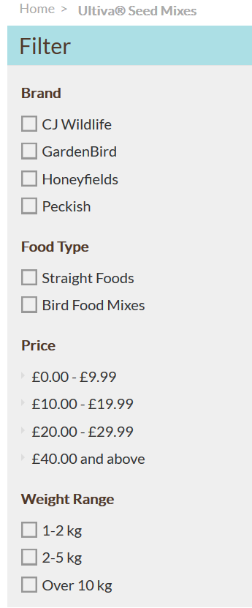





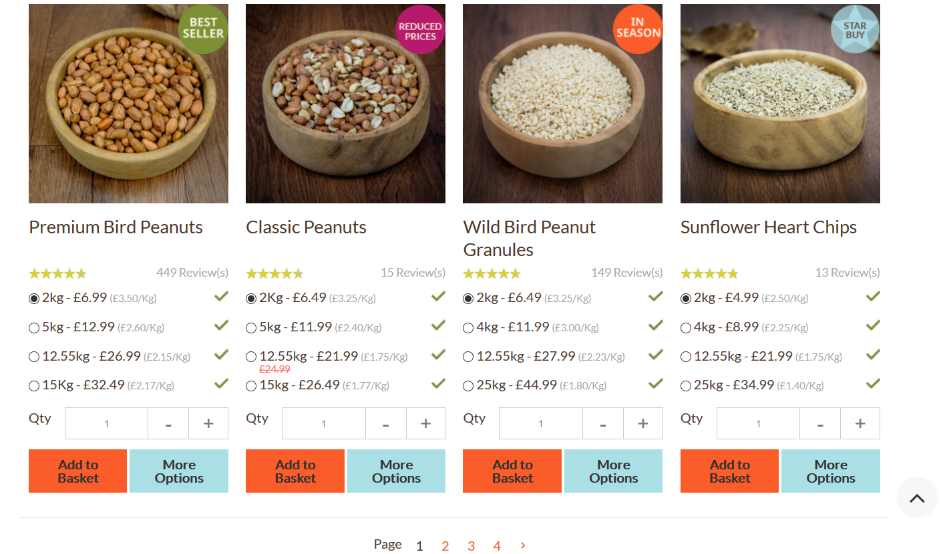

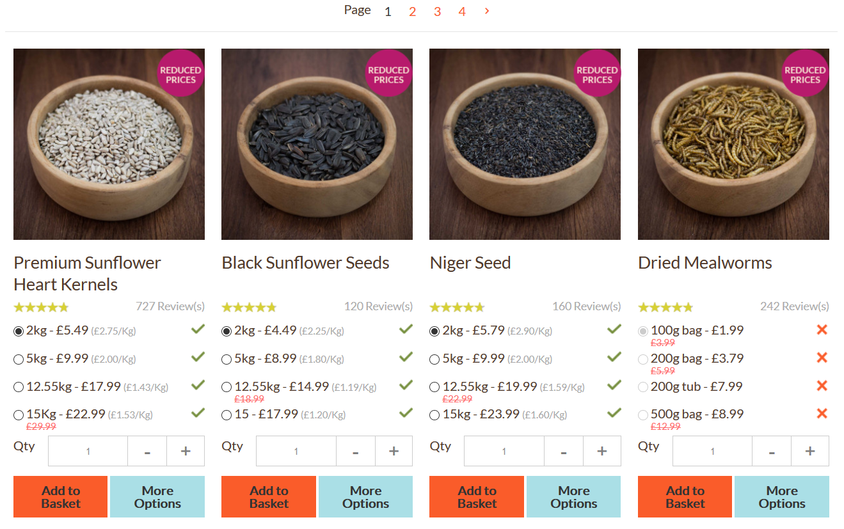

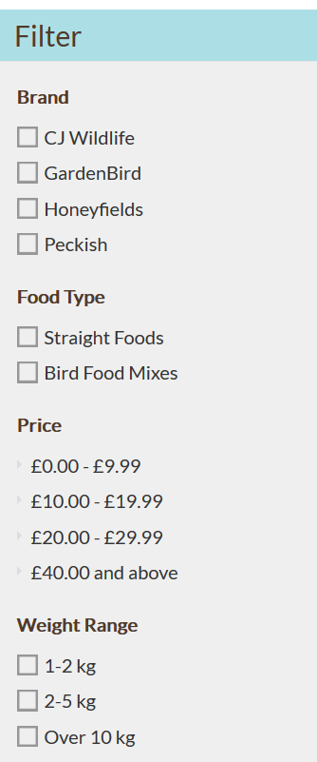

**Straights**

Choose from our range of premium quality straight garden bird food including peanuts (tested to ensure they are aflatoxin free), sunflower seed hearts, niger seed and peanut granules. The latter are ideal for feeding fledglings from seed feeders at this time of year.   
  
[Bird Peanuts](https://www.gardenbird.co.uk/straight-foods/bird-peanuts.html) | [Dried Mealworm](https://www.gardenbird.co.uk/straight-foods/dried-mealworms.html) | [Niger Seed](https://www.gardenbird.co.uk/straight-foods/niger-seed.html) | [Sunflower Hearts](https://www.gardenbird.co.uk/straight-foods/sunflower-hearts-and-seeds.html) | [Other](https://www.gardenbird.co.uk/straight-foods/other.html)







**Suets**

Suet foods are loved by birds and provide an essential energy boost throughout the year. Why not try our delicious high energy-packed bird pellets and suet pellets, perfect for bird tables & ground feeder trays and loved by all birds.   
  
[Suet Balls](https://www.gardenbird.co.uk/suet-bird-food/wild-bird-suet-balls.html) | [Suet Blocks](https://www.gardenbird.co.uk/suet-bird-food/suet-blocks.html) | [Suet Cakes](https://www.gardenbird.co.uk/suet-bird-food/suet-treat-cakes.html) | [Suet Coconut](https://www.gardenbird.co.uk/suet-bird-food/suet-coconut-shells.html) | [Suet Pellets](https://www.gardenbird.co.uk/suet-bird-food/suet-pellets.html) | [Suet Peanut Butter](https://www.gardenbird.co.uk/suet-bird-food/suet-peanut-butter.html) | [Suet Logs](https://www.gardenbird.co.uk/suet-bird-food/suet-logs.html)

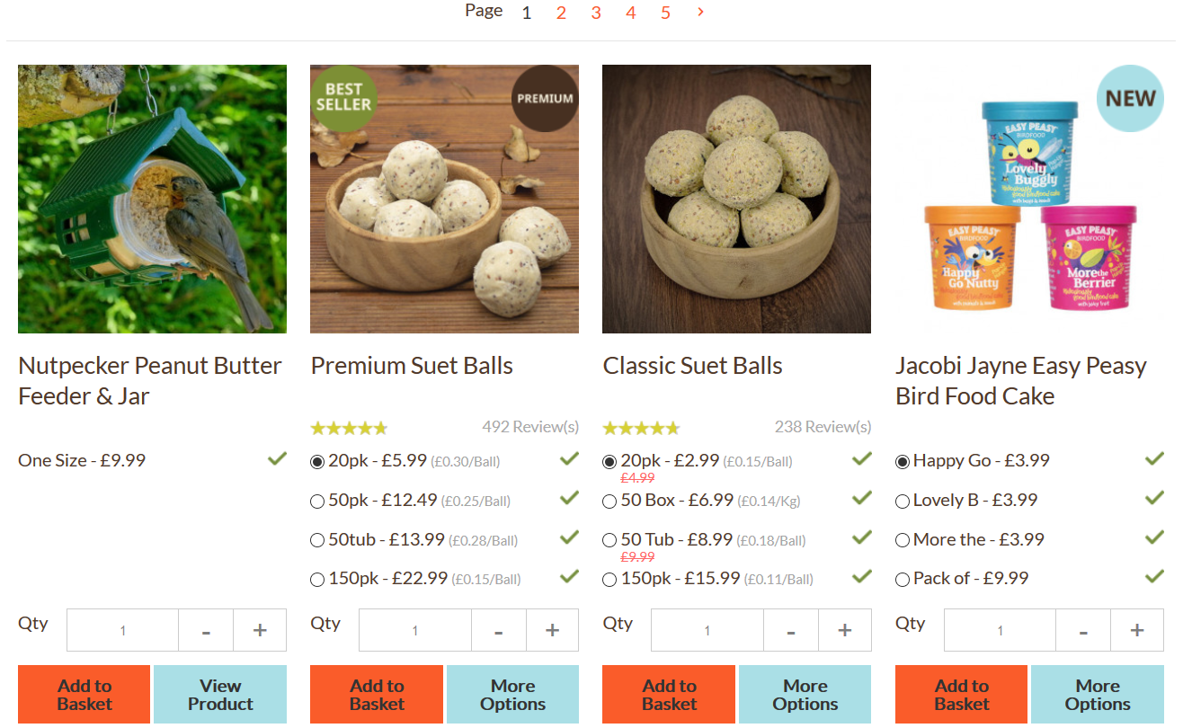

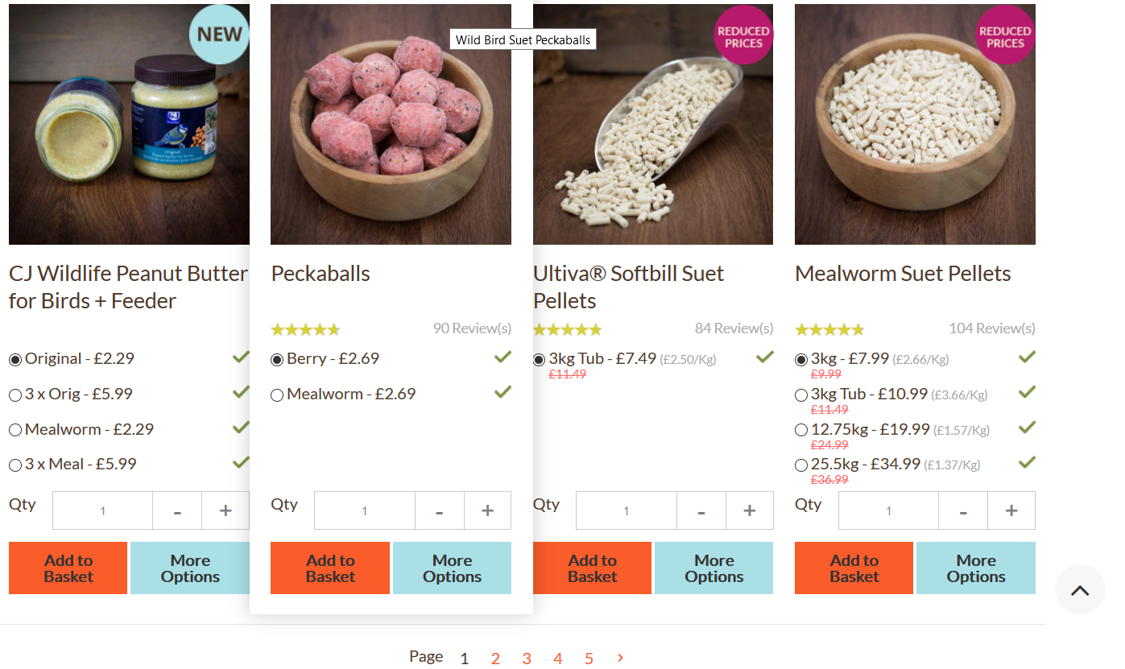





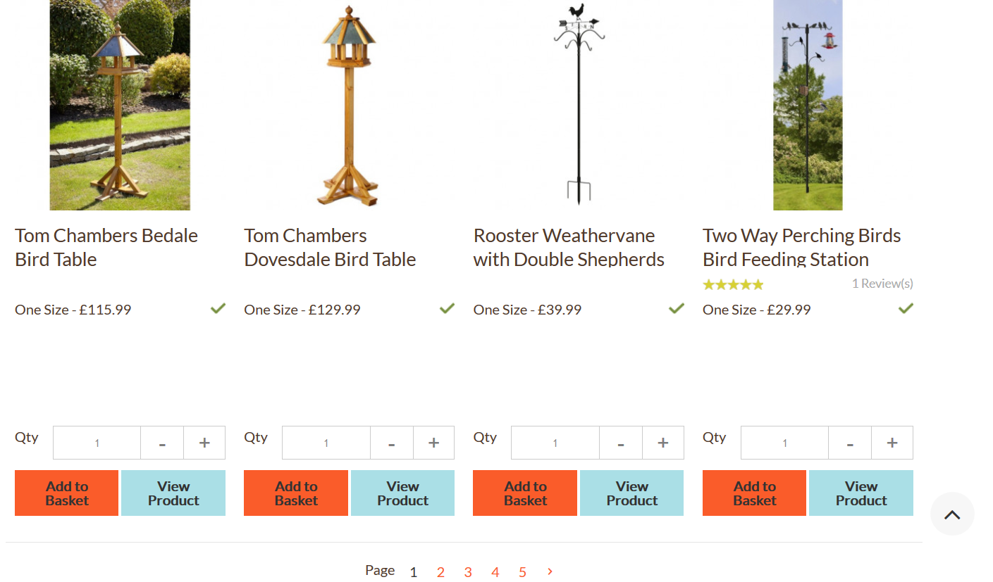

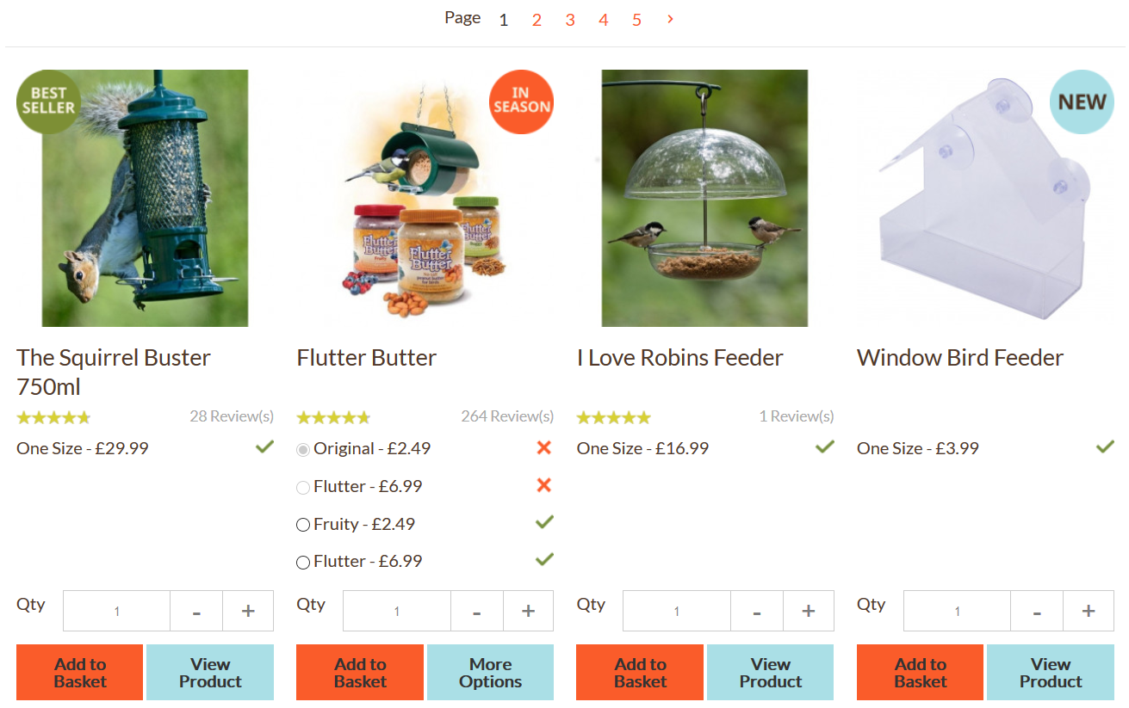



**Bird Feeders**

Within our huge selection you'll find the perfect garden bird feeder and bird table for every type of food and every location. [Seed feeders](https://www.gardenbird.co.uk/bird-feeders/bird-seed-feeders.html), [nut feeders](https://www.gardenbird.co.uk/bird-feeders/bird-nut-feeders.html), worm feeders, [suet feeders](https://www.gardenbird.co.uk/bird-feeders/treat-block-suet-ball-feeders.html), hanging feeders, [window feeders](https://www.gardenbird.co.uk/bird-feeders/window-feeders.html) and more - if it’s a wild bird feeder you need, we've got it!   
  
[Table & Ground](https://www.gardenbird.co.uk/bird-feeders/bird-tables.html) | [Feeding Stations](https://www.gardenbird.co.uk/bird-feeders/feeding-stations.html) | [Peanut](https://www.gardenbird.co.uk/bird-feeders/bird-nut-feeders.html) | [Seed](https://www.gardenbird.co.uk/bird-feeders/bird-seed-feeders.html) | [Squirrel resistant](https://www.gardenbird.co.uk/bird-feeders/squirrel-resistant-bird-feeders.html) | [Niger](https://www.gardenbird.co.uk/bird-feeders/thistle-feeders.html) | [Suet](https://www.gardenbird.co.uk/bird-feeders/treat-block-suet-ball-feeders.html) | [Window](https://www.gardenbird.co.uk/bird-feeders/window-feeders.html) | [Mealworm](https://www.gardenbird.co.uk/bird-feeders/mealworm-feeders.html) | [Exclusive Feeders](https://www.gardenbird.co.uk/bird-feeders/gbs-exclusive-range.html)





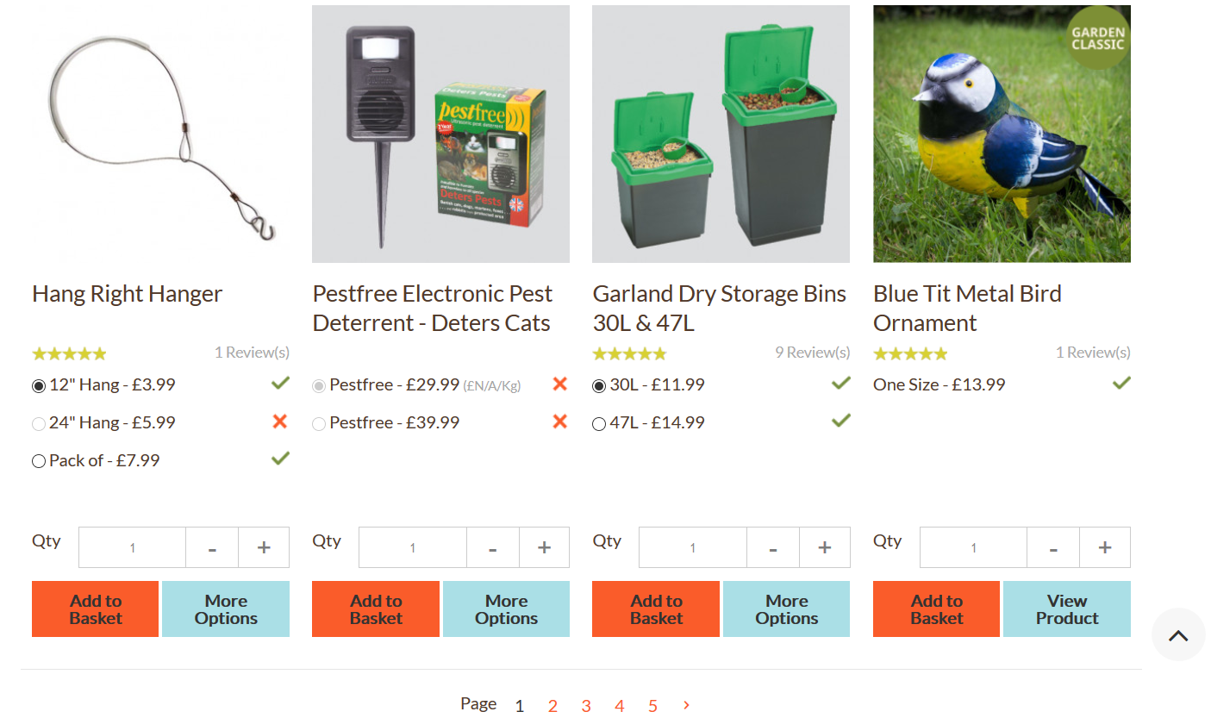

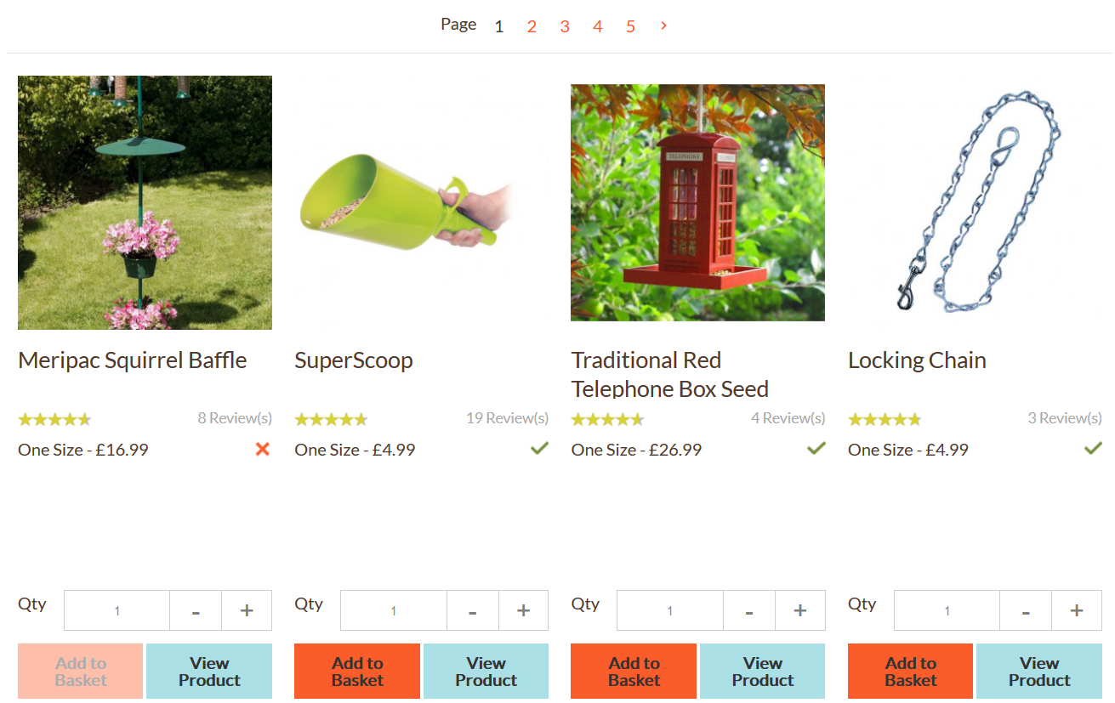

**Accessories**

If you're looking for accessories for feeding your garden birds, then take at a look at our amazing range. We stock bird accessories that range from feeder poles, trays and hooks, to accessories to deter birds' natural predators. So if you're looking for bird accessories, you're sure to find the accessory for the job right here.   
  
[Bird Baths](https://www.gardenbird.co.uk/accessories/bird-baths.html) | [Nest Boxes & Accessories](https://www.gardenbird.co.uk/accessories/nest-boxes-and-accessories.html) | [Gifts](https://www.gardenbird.co.uk/accessories/gifts.html) | [Hygiene & Safety](https://www.gardenbird.co.uk/accessories/hygiene-and-safety.html) | [Repellents](https://www.gardenbird.co.uk/accessories/repellents.html) | [Cameras](https://www.gardenbird.co.uk/accessories/nest-boxes-and-accessories/cameras.html) | [Garden Ornaments](https://www.gardenbird.co.uk/accessories/garden-ornaments.html)







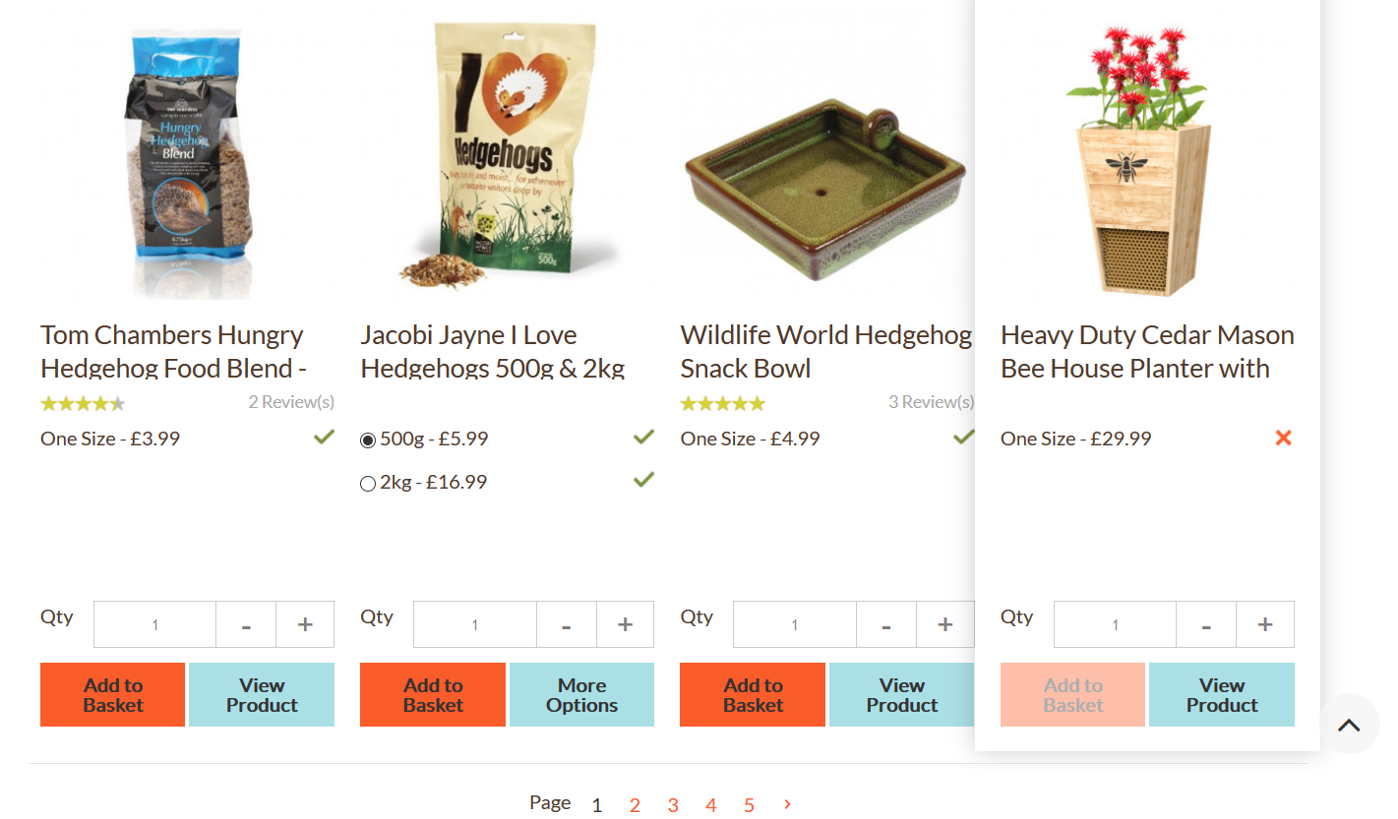

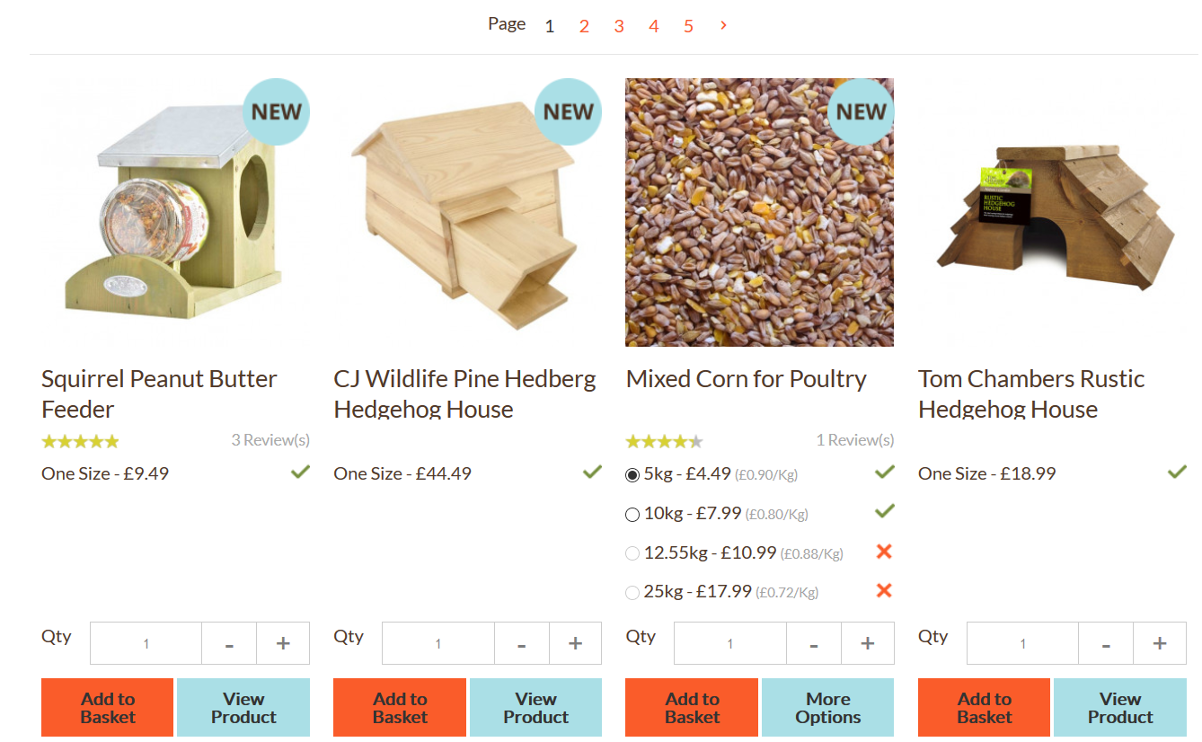

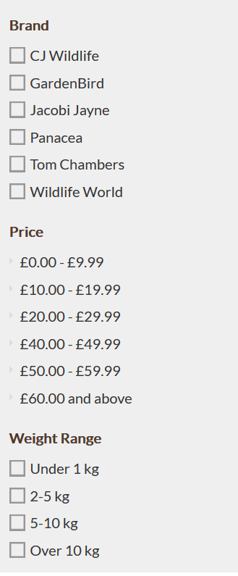

**Wildlife & Pets**

Create an authentic wildlife haven in your garden with our extensive range of wildlife houses and wildlife food mixes that will attract all kinds of animals and insects into your garden. Plus we've recently added wildlife friendly shrubs and perennials to the range so you can create a wildlife garden with longevity!   
  
[Wildlife Food Mixes](https://www.gardenbird.co.uk/wildlife/wildlife-food-mixes.html) | [Wildlife Houses](https://www.gardenbird.co.uk/wildlife/wildlife-houses.html) | [Hedgehog](https://www.gardenbird.co.uk/wildlife/hedgehog.html) | [Bee Care](https://www.gardenbird.co.uk/wildlife/bees.html)





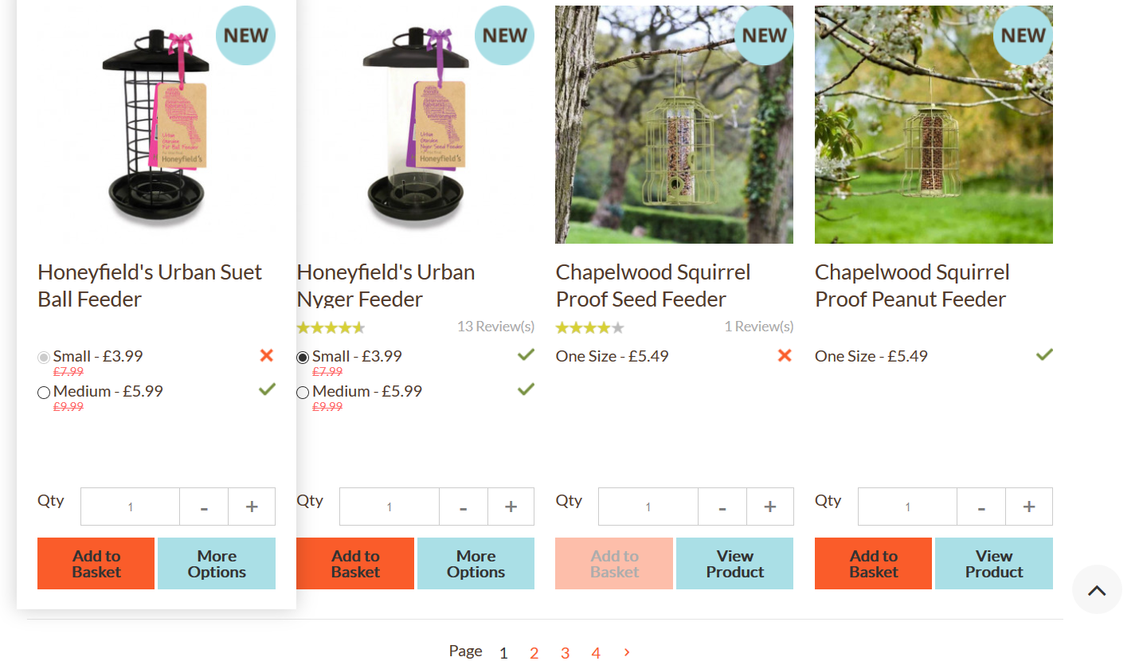

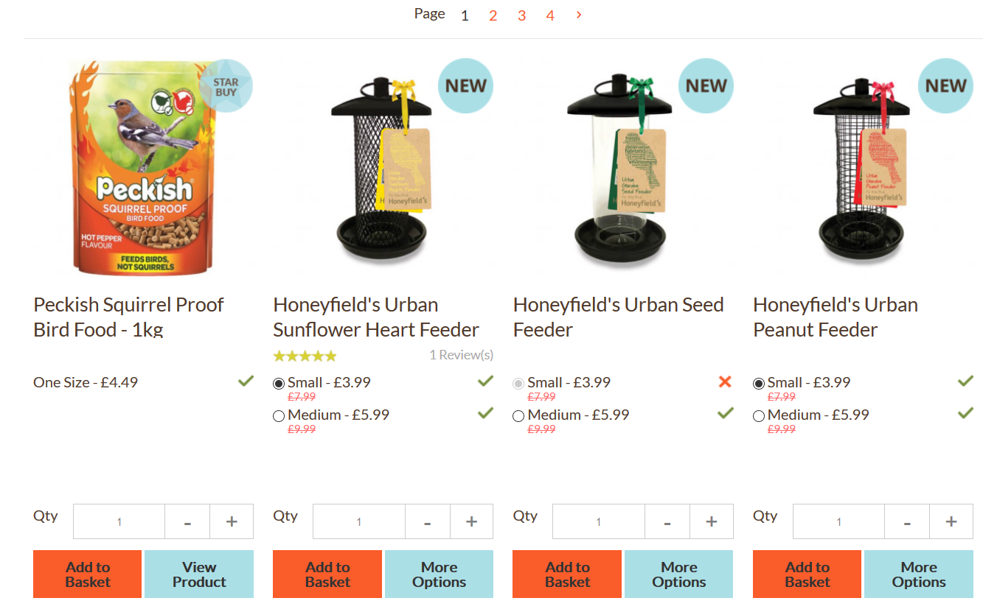

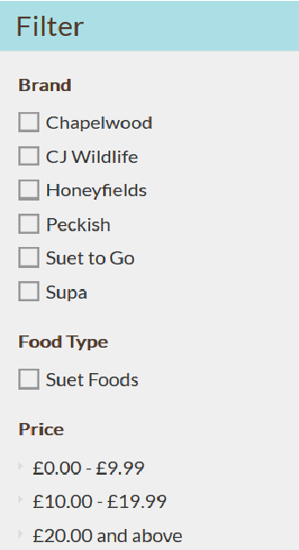

**New In**

Welcome to our “New In” category where we feature all the new bird foods, feeders and accessories we have added to our ranges together in one convenient place. We are constantly looking for new products that will bring more birds into your garden, make bird feeding easy or look great.





